Docker build:
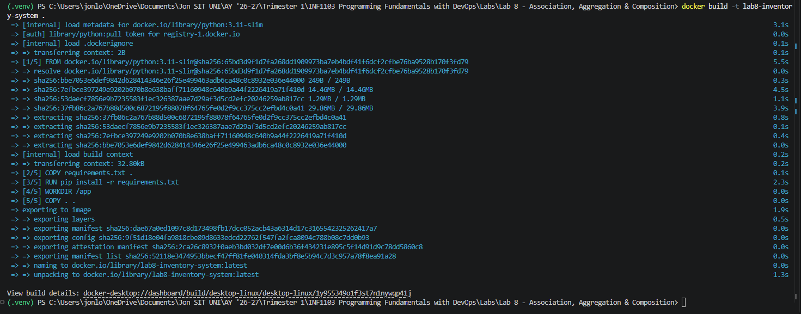
Docker images:
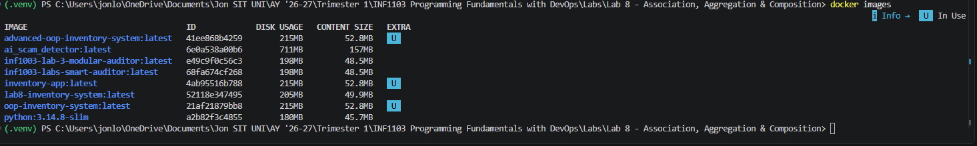
Program run:


